**Overview**

The purpose of this project is to perform an exploratory analysis of the WHO’s data on global alcohol consumption during the years spanning from 2010 to 2019, with the goal of answering the following questions:

1. How has alcohol consumption changed during the 2010s in the USA? Which type of alcohol is the most popular there?
2. How have alcohol consumption numbers changed during the 2010s, worldwide? Which type of alcohol is the most popular?
3. Which country consumes the most alcohol in general?
4. Which country consumes the most of each type of alcohol?

The data used in this analysis comes from the [WHO’s record of alcohol consumption per capita](https://apps.who.int/gho/data/node.main.A1039?lang=en), kept for public viewing on their website. All numbers recorded are the amount of consumption per capita, in liters of pure alcohol.

Some things to note:

1. For some countries, all consumption numbers in the “Other alcoholic beverages” category are zero. This is most likely because, according to some, any alcoholic beverage that isn’t a beer or wine is a spirit; since this dataset cites different sources for different countries, it is likely that some sources lumped in all non-beer/wine drinks as spirits.
2. In our data analysis, we will often refer to visuals created from an interactive report made using PowerBI, which can be found in the Github repository for this project as “Interactive Alcohol Report.pbix”.
3. We will also be performing analysis on smaller tables that were queried from the full dataset using MySQL; the SQL scripts used, and the corresponding output tables, can also be found in the Github repository.
4. **Changes in consumption in the USA**

Let’s examine the regression line of alcohol consumption against the year for dataset containing the USA only:

By visual inspection, it appears that alcohol consumption generally increased over time in the USA during the 2010s. For more precise analysis, let’s look at the regression summary produced by R:

Call:

lm(formula = Total_Consumption ~ Year, data = usa_data_by_year)

Residuals:

Min 1Q Median 3Q Max

-0.095455 -0.036470 -0.004182 0.027121 0.124970

Coefficients:

Estimate Std. Error t value Pr(>|t|)

(Intercept) -61.268182 14.140440 -4.333 0.00250 **

Year 0.034788 0.007019 4.956 0.00111 **

---

Signif. codes: 0 ‘***’ 0.001 ‘**’ 0.01 ‘*’ 0.05 ‘.’ 0.1 ‘ ’ 1

Residual standard error: 0.06376 on 8 degrees of freedom

Multiple R-squared: 0.7543, Adjusted R-squared: 0.7236

F-statistic: 24.56 on 1 and 8 DF, p-value: 0.001112

It appears that the year does have a significant impact on total consumption in the USA; the slope of the line is about 0.035, suggesting that alcohol consumption increased in the USA, on average, by about 0.035 liters per capita during the 2010s. The P-value of 0.00111 tells us that this estimate is made with a high level of confidence, and the adjusted R-square value of 0.7236 tells us that the year explains about 72% of the variation in total consumption within this dataset. It is safe to conclude that alcohol consumption increased significantly in the USA during this timespan.

Let’s assess the relative popularity of the different types of alcohol in the USA, using a pie chart pulled from the interactive report:

During the 2010s, beer was the most popular type of alcohol in the USA, making up about 47% of total consumption; spirits follow at roughly 35% of consumption, and wine makes up the remaining 18%. Note that no consumption was marked as “other”; presumably, the source for the USA data only categorized alcoholic beverages as beer, spirits, or wine.

1. **Changes in consumption worldwide**

Let’s examine the regression line of average alcohol consumption against the year for the full dataset:

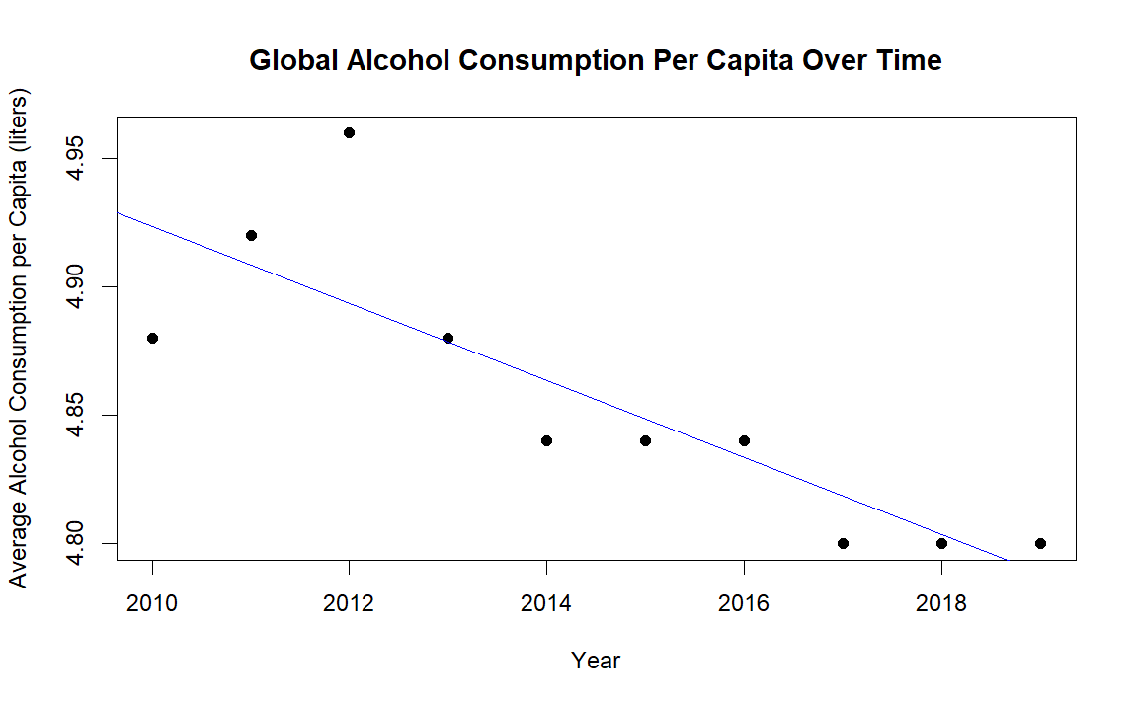

By visual inspection, it appears that alcohol consumption decreased significantly over the course of the 2010s. For more precise analysis, let’s examine the regression summary produced by R:

Call:

lm(formula = Average_Consumption_Rate ~ Year, data = global_avg_by_year)

Residuals:

Min 1Q Median 3Q Max

-0.04364 -0.01594 -0.00097 0.01018 0.06642

Coefficients:

Estimate Std. Error t value Pr(>|t|)

(Intercept) 35.134545 6.837098 5.139 0.000886 ***

Year -0.015030 0.003394 -4.429 0.002201 **

---

Signif. codes: 0 ‘***’ 0.001 ‘**’ 0.01 ‘*’ 0.05 ‘.’ 0.1 ‘ ’ 1

Residual standard error: 0.03083 on 8 degrees of freedom

Multiple R-squared: 0.7103, Adjusted R-squared: 0.6741

F-statistic: 19.61 on 1 and 8 DF, p-value: 0.002201

It appears that the year did have a significant negative effect on the average alcohol consumption rate; the average rate decreased by about 0.015 liters per capita. We have a highly significant P-value of 0.002201, and the adjusted R-squared value of 0.6741 tells us that the year explains about 67% of the variation in the average consumption rate.

Lets assess the relative popularity of the different types of alcohol globally, using a pie chart pulled from the interactive report:

Like in the USA, beer is the most popular type of alcohol globally, followed by spirits and then wine; however, beer is slightly less popular globally than in the USA, making up only 40% of total consumption, with spirits and “other” types combining to make up about 40.04% of total consumption, only very slightly less than beer.

1. **Countries which consume the most alcohol**

We can answer this question using a table pulled from the interactive report:

The total consumption of alcohol per capita is by far at its highest in Estonia, with roughly 151 liters being consumed per capita across the 2010s. Lithuania, Czechia, the Cook Islands, and Austria round out the top 5.

1. **Countries which consume the most of each type**

We can also answer this question using tables pulled from the interactive report:

Filtered for beer:

Filtered for wine:

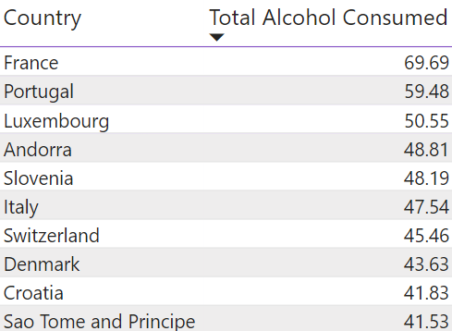

Filtered for spirits:

Filtered for other categories:

From these tables, we can see that beer consumption was dominated by Czechia, Austria, and Germany. Wine was dominated by France, Portugal, and Luxembourg, while spirits were most consumed in the Cook Islands, Estonia, and Dominica. Finally, beverages categorized as “other” were most consumed in Uganda, Tanzania, and Rwanda.

**Conclusions**

To answer each of our initial questions:

1. The data suggests that alcohol consumption in the USA increased significantly between 2010 and 2019, by about 0.035 liters per capita per year. Beer is the most popular type of alcohol in the USA by a significant margin, followed by spirits and then wine.
2. The data suggests that alcohol consumption across the world decreased significantly between 2010 and 2019, by about 0.015 liters per capita per year. Beer is still the most popular type, followed by spirits and then wine; however, beer is slightly less popular globally than in the USA, with spirits and “other” being significantly more popular.
3. The country which consumed the most alcohol per capita was Estonia.
4. The countries which consumed the most of each type per capita were France (wine), Czechia (beer), and the Cook Islands (spirits); the country which consumed the most alcohol labelled as “Other” was Uganda.

Further studies may seek to gather and investigate data from 2020 onward and determine the effect of the COVID-19 pandemic on alcohol consumption. It may also be of interest to gather and analyze data on sales of various major brands of alcohol, and see how they have changed over time in relation to the overall consumption of alcohol. It appears that alcohol consumption is on the rise in the USA, but somewhat declining worldwide; are large brands seeing this phenomenon reflected in their revenue streams?

**Works Cited**

“Recorded Alcohol per Capita Consumption, from 2010.” World Health Organization, World Health Organization, 13 June 2022,

< <https://apps.who.int/gho/data/node.main.A1039?lang=en> >.